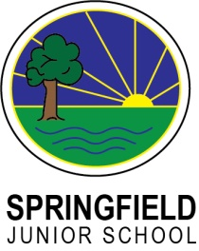
Nut Allergy Awareness Policy

Purpose
The purpose of this policy is to
- Raise awareness about allergies to all our school community
- Ensure we provide a safe learning environment for all
- Give assurance to those children/families with severe allergies that we take the management of these seriously.

Aim
We are not a nut-free school but we aim to be as nut-free as we can. It is impossible to provide an absolute guarantee that no nuts will be brought onto the premises but we will strive to minimise this as much as we can.

Management
We ask that all members of the school community manage the day to day application of this policy in the following ways:
- Parents and carers are requested NOT to send food to school that contains nuts.
This includes all types of nuts, peanut butter, nutella, cereal/chocolate bars and any other food containing nuts.
- Staff will be alert to any obvious signs of nuts being brought in, but they will not inspect all food brought into school.
- Children that DO bring in food that does contain nuts or nut products will be asked to eat that food away from any child with a nut allergy and to wash their hands before going to play.
- If any actual nuts are found, they will be bagged up and sent home and this child will be asked to eat lunch away from other children and wash their hands before going out to play.
- Children will be asked NOT to share food.
- Children will be encouraged to wash hands/sanitise before and after eating.
- Some staff are trained in understanding and dealing with Anaphylaxis (severe allergic reactions) and will use this training as the need arises.
- The school dinner providers will ensure all cooked food is nut-free.

Promotion
The policy will be promoted by:
- A copy of this policy being made available to all parents and carers.
- Staff being informed and provided with training opportunities.
- Children being informed via teachers and support staff.
- Publication of this policy on the school website.
- Issue of the policy in the new admission packs.

