King Snake

It is a strange day for Jack. What will happen to him? What does his future hold?

2020
Marie.Hardy
Written By Noah Partridge, 3M
4/27/2020

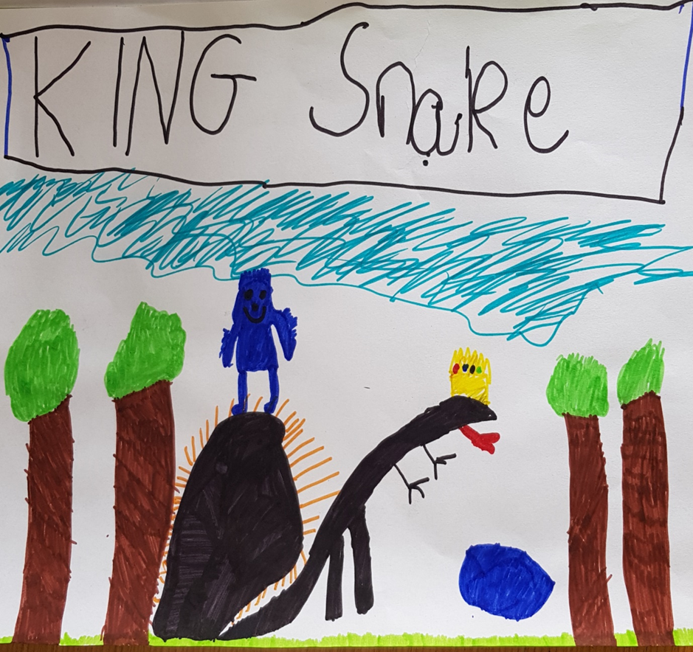

King Snake
Once there was a determined, fearless man and he was called Jack. When Jack caught a Black Mamba it spat venom at him! He was ok. Suddenly… he shook and turned matte black! Then his tongue was fork-shaped. He also grew a tail! He was becoming a Black Mamba! He quickly ran home but he noticed something, he wasn’t running, he was slithering! When he got home he forgot about everything he owned. He was starting a new life as a poisonous snake. Jack felt confused and puzzled because he never knew this was going to happen. “What’s happened to me? Are my friends going to be scared?” muttered Jack. He then texted his friend Max and told him to come over to his house. When he arrived, Max was feeling happy about seeing his friend but then Jack identified himself… Max was terrified and sprinted out in fear. Jack was worried and embarrassed. Next, he went straight to bed. After that chaotic day, Jack went for a walk. Then he saw a fast blue hedgehog and shouted “Sonic is that you?” Yes how do you know?” I’ve read all about you in the comics.” Do you want to become friends?”

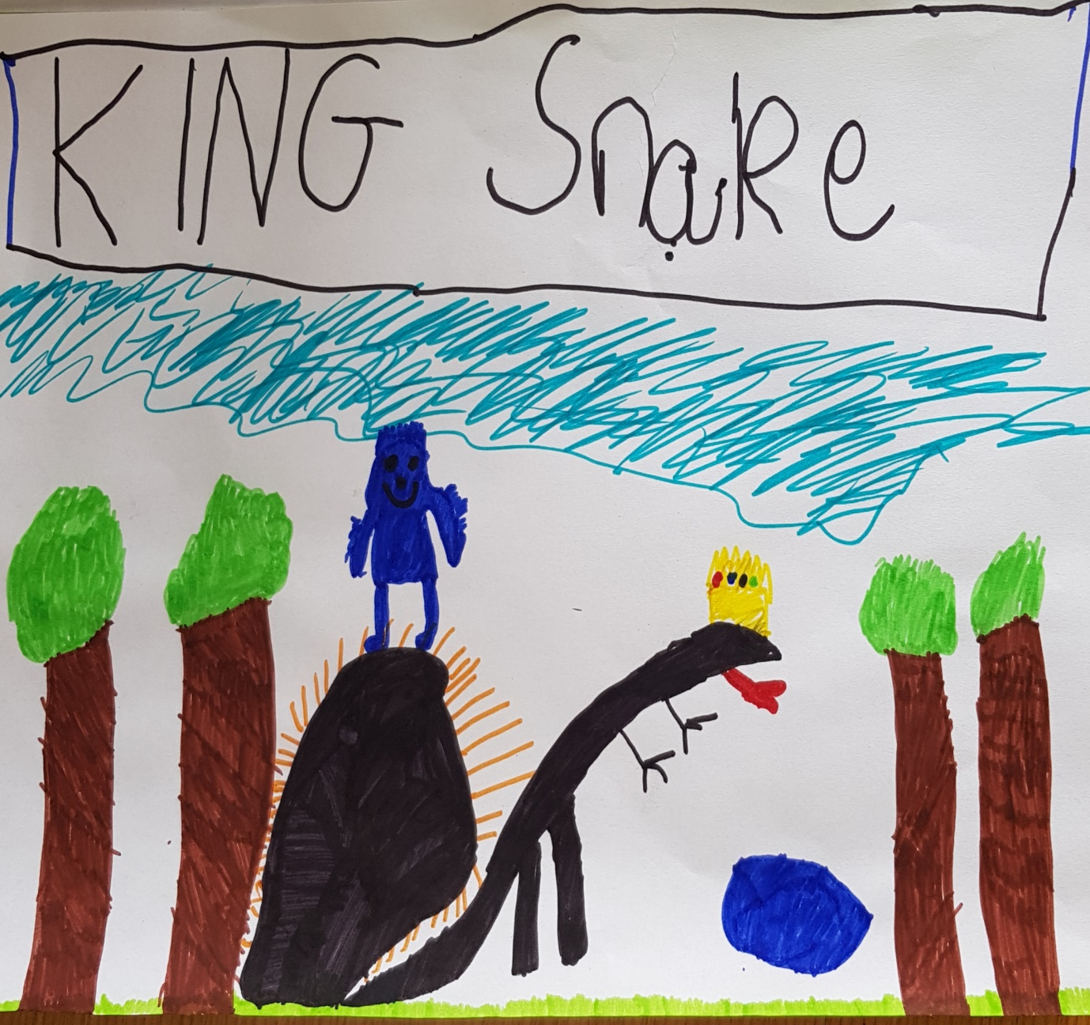

Written by Noah Partridge, 3M

