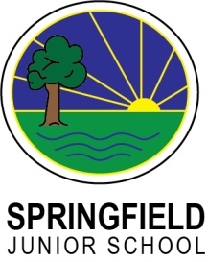**My Key Objectives:**

**YR 4 - Performing Arts**

**Dance:**

**I can learn a sequence movement**

**I can improvise.**

**I can develop flexibility, strength and technique**

**I explore the movement from a range of cultures and genres**

**I can create a piece to meet a given purpose**

**I can confidently perform rehearsed movement in duets/trios/unison to a group of friends or parents**

**I can use my facial expressions to enhance performance.**

**I begin to show evidence of musicality through performance.**

**Drama:**

**I can understand what proxemics**

**I can play drama games**

**I can understand the importance of a rehearsal process**

**I can complete a full rehearsal to performance process.**

**I can begin to consider purpose and audience**

**I can confidently stand in front of a class of parents and friends**

**I can use different speaking volumes**

**I can begin to understand directional vocab (up/downstage, stage left/right)**

**I can retell the main events in a short drama piece in order**

**I can make suggestions to improve pieces of drama**

**Music:**

**I can sing, in a group demonstrating some accuracy, fluency, control and expression**

**I can play a musical instrument, in solo and a group demonstrating some accuracy, fluency, control and expression.**

**I can improvise music, using my voice or a musical instrument**

**I can compose, varying the elements of pitch, duration, tempo, texture, timbre, dynamics in my music.**

**I can record my compositions in writing, using one type of notation.**

**I have experienced high-quality live and recorded music drawn from different traditions, composers and musicians.**

**I am beginning to understanding a range of music by having an awareness of the social and cultural context in which it was created.**

**I can discuss the lives of a number of key people in the history of music, and how this influenced their music.**