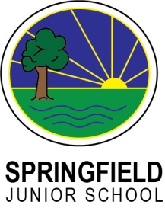**My Key Objectives:**

**YR 3 - Performing Arts**

**Dance:**

I can learn a sequence of movement

I can use improvise movement

I can develop flexibility, strength and technique

I can confidently perform rehearsed movement to friends or parents

I can begin to use my facial expressions in a performance.

I begin to show evidence of musicality through performance.

**Drama:**

I can understand what proxemics are

I can take part in drama games

I can understand why a rehearsal process is important

I can complete a full rehearsal to performance process

I can use different speaking volumes in different contexts

I can watch and listen to a short drama piece.

**Music:**

I can sing in a group , demonstrating some accuracy, fluency, control and expression.

I can improvise music, using my voice or a musical instrument

I can play a musical instrument, in solo and group contexts, demonstrating some accuracy, fluency, control and expression.

I can listen to a musical phrase and repeat it back using my voice or an instrument.

I can listen to and verbally respond to a composition of my peers.

I can discuss the lives of a number of key people in the history of music, and how this influenced their music.