Springfield Junior School
Behaviour Policy

Prepared by | Louise Everitt/Kim Cook
Approved by the Committee/Governing body | September 2021
Review date | September 2022

Springfield Behaviour Policy 2021

The Behaviour Policy directly relates to:
Attendance Policy Special Educational Needs /Disabilities Equality Policy
School Ethos and Values Curriculum Policies (including Jigsaw) Safeguarding and Child Protection

Aims and Expectations

At Springfield Junior School, our primary aim is that every member of the school community feels valued and respected. We are a caring community, whose ethos is built on core values of mutual trust and respect for all, directly linked to British Values. This policy aims to help children to grow in a safe and secure environment, and to become positive, responsible and increasingly independent members of the school community. As a result, this allows learners to uphold our school values:

Persevere + Believe + Learn = Achieve

The school behaviour policy is therefore designed to support the way in which all members of the school can live and work together in a supportive way. The Behaviour Policy aims to give every member of the school community a voice and allow them to raise concerns if they have them.

The Behaviour Policy is a means of promoting good relationships, so that people can work together with the common purpose of helping everyone to learn. The school expects every member of the school community to behave in a considerate way towards others, aiming to promote good behaviour, rather than merely deter anti-social behaviour.

All children are treated equally and the Behaviour Policy is implemented in a consistent way, taking into account Special Educational Needs and making reasonable adjustments where required.

Convention on the Rights of the Child

As a school that respects the rights of the children and adults in our school family, community and beyond, it is important to us that this policy adheres to articles from UNICEF’s Convention on the Rights of the Child (UNCRC).

Our School Charter September 2021
• Article 28 – We have a right to learn
• Article 12 and 13 – We have a right to be heard and different opinions are respected.
• Article 24 – We have the right to be healthy.
• Article 2 – We have a right to be treated equally.
• Article 19 – We have the right to be safe.
• Article 31 – We have the right to relax, play and join a variety of groups.

Each classroom has their own individual charters based on the articles deemed important by each class, and the rights ambassadors have created a charter for the school:

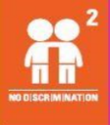
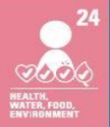
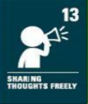
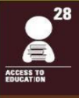
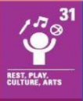

Rewards and Consequences

Rewards

Our main principle is that whenever possible intervention should be on the basis of reward. The school enjoys celebrating achievements and acknowledges the efforts and successes of children, both in and out of school. We firmly believe that expectations for behaviour should be upheld by all pupils throughout the school day and when they are representing the school.

Class Rewards include: | Whole School Rewards:
- Verbal or written praise  - Stickers for learning behaviours linked to our school motto.  - stamps and smiley faces  - Team Points for positive behaviour choices  - Displaying work  - Pupils sent to Senior Leadership, or other members of staff, to share learning  - Annual school reports and termly updates to parents  - Contact with parents to praise children | - Weekly Celebration Assembly  - Regular newsletters  - Weekly Team Points stickers counted and shared  - Special stickers from SLT

Consequences

Inappropriate behaviour in school is dealt with in a variety of ways and it must always be seen as being appropriate to the situation and children involved, relating to the behaviours observed (see Appendix 1.1 and Appendix 1.2).

Any consequences provided allows the pupils to reflect on the behaviours they have displayed and what they would do differently in future. Within lessons, a clear approach to behaviour is followed by all staff and these are shared with pupils explicitly.

Consequences used within Class (see Appendix 1.1):

Pupils’ behaviour is excellent and rewards are provided  Praise provided via agreed approach (see Rewards) | Step 1:  Verbal Warning | Step 2:  Pupil is moved to another part of the classroom | Step 3:  Pupil is asked to sit outside the classroom for five minutes | Step 4:  Lose 15 minutes of break time and complete a Reflection Sheet (Appendix 2.0) in the Year Leader’s classroom.  These are recorded and reviewed termly | Step 5:  Work in isolation, as directed by a member of SLT  Parents informed via an email or phone call  CPOMS entry | Step 6:  Headteacher/Deputy Head’s office to work in isolation  Parents informed with a phone call or formal meeting  CPOMS entry

Consequences at Break Times (see Appendix 1.2):

Step 1:  Verbal warning | Step 2:  Asked to stand to the side to reflect upon behaviour | Step 3:  10 minutes in the Hall. The class teacher informed of this. | Step 4:  Pupil sent to Year Group Leader.  Alternative break time required for the pupil.  Incident recorded on CPOMS by Year Leader.  Escalated to SLT if required

At Springfield Junior School, our aim is to be transparent with parents and work together to develop good behaviour choices. Parents are welcome to speak with their child’s class teacher regarding any consequence being provided in school.

There may be incidences where staff members are unable to move sequentially through the flow chart due to the negative behaviour being displayed by the pupil. There may be some cases where a child displays physical aggression towards others or shows defiance/rudeness towards a member of staff. These behaviours can all be identified in the Unacceptable Behaviours section in the appendix (Appendix 1.1 and Appendix 1.2).

Restorative Justice

Through discussion, and completion of Reflection Sheets, see Appendix 2.1, pupils are encouraged to understand how their behaviour affects others and also how they can make improvements. Teaching staff, including Year Leaders, use key questions to enable pupils to discuss their behavioural choices and how resolutions can be found.

Exclusions

On the rare occasion that pupils display extremely serious behaviour or continue to display poor behaviour choices after the sanctions above, fixed term exclusions may also be used.

Depending on the nature of the offence, this may include immediate, permanent exclusion. Only the Headteacher (or the Acting Headteacher) has the power to exclude a pupil from school. See the exclusion policy for further information.

The Role of Springfield Junior School Staff

All staff in school have high expectations of the children in terms of behaviour, and they strive to ensure that all children work to the best of their ability. All members of staff model positive behaviours when working alongside pupils. In managing behaviour, staff are expected to explicitly share rules, have high expectations of behaviour and apply a range of strategies in class.

The use of restraint is rare at Springfield Junior School. There will however be occasions when some form of physical contact is inevitable, for example if a child has an accident or is hurt or is in a situation of danger to themselves or others around them. However, at all times the Department for Education’s Reasonable Force Guidance is adhered to (this can be referenced at: https://assets.publishing.service.gov.uk/government/uploads/system/uploads/attachment_data/file/444051/Use_of_reasonable_force_advice_Reviewed_July_2015.pdf

Staff are trained about their responsibilities regarding behaviour, and strategies for behaviour support through the BehaviourSafe course ‘Behaviour and the Law.’

Parental Support

We actively work with parents to establish ways of working together to improve children’s behaviour. At Springfield Junior School, we believe in a joined-up approach. The Family Support Worker works in collaboration with parents and other external agencies. Within school, we monitor behaviour through Reflection Sheets and also using our whole school tracking software (CPOMS).

In some instances, there may be the need to implement an individual behaviour support plan or target chart. These are then reviewed regularly with parents and children. Emotional interventions such as ELSA or Thrive may be undertaken with trained practitioners in school, supporting behavioural choices of pupils. Behaviour plans are created after a number of incidents appear in a short period of time, including the completion of Reflection Sheets, and parents are requested to come into school to become actively involved with what steps can be put in place moving forward.

Additional privileges children receive may be withdrawn as a result of repeated concerning behaviour choices – This may include access to extra-curricular trips/ activities. These decisions are made by Year Leader and members of SLT after consideration of the safety of all pupils and any additional measures that could be implemented.

Reporting Grievances

This flow chart outlines the steps which should be taken when reporting concerns about how a child has been treated regarding their behaviour:

Initially contact the class teacher

If the concern remains, contact the Headteacher

In the next instance, the Governing Body.

If these discussions cannot resolve the problem, a formal grievance or appeal process can be implemented.

Information regarding this can be found on the policies page of the Springfield Junior website: https://www.springfieldjuniors.org.uk/policies.html

Reviewing the Behaviour Policy

The Governing Body reviews the Behaviour Policy every year. Governors may, however, review the policy earlier than this, if the government introduces new regulations, or if the governing body receives recommendations on how the policy might be improved.

Appendix 1.1
This list outlines a number of unacceptable behaviours which may be seen during lessons and also during break times. There may be instances where the consequences provided are sequential. However, members of staff will assess each incident and deal with it accordingly, using an appropriate sanction:

During Lessons
Step 1  Verbal Warning | -Talking whilst and adult is talking  -Calling out  -Distracting others  -Disrespect to someone’s property  -Rocking on a chair  -Pushing or knocking others  -Not being punctual to lessons
Step 2:
Pupil is moved to another part of the classroom and their name written on the board
Step 3:
Pupil is asked to sit outside the classroom for five minutes

Step 4:  Lose 15 minutes of break time and complete a Reflection Sheet (Appendix 2.0) in the Year Leader’s classroom. These are recorded and reviewed termly | -Refusal to attempt work  -Talking school equipment without permission  -Talking things that belong to others  -Defiance/mimicking an adult  -Damaging property intentionally  -Deliberate physical aggression
Step 5:
Work in isolation, as directed by a member of SLT
Parents informed via an email or phone call
CPOMS entry

Step 6:  Headteacher/Deputy Head’s office to work in isolation  Parents informed with a phone call or formal meeting  CPOMS entry | -Extreme instances of verbal/physical -aggression  -Premeditated violence – towards a child or adult  -Persistent refusal to follow an adult’s instruction which affects other pupils’ safety  -Peer-on-peer abuse

Appendix 1.2
Break Times
Step 1:  Verbal warning  Step 2:  Asked to stand to the side to reflect upon behaviour | Being physical towards others  Disrespecting other peoples’ property
Step 3:  10 minutes in the Hall with a sand timer. The class teacher informed of this. | Rudeness towards an adult e.g. mimicking an adult, personally insulting someone  Throwing equipment/dangerous behaviour towards other pupils  Refusal to follow an adult’s instructions  Inappropriate behaviour in the Hall during lunchtime  Being physically aggressive towards another pupil
Step 4:  Pupil sent to Year Group Leader. Alternative break time required for the pupil.  Incident recorded on CPOMS  Escalated to SLT if required. | Seriously injuring another child, with intent  Continuous bullying of another child  Persistent refusal to follow an adult’s instructions which affects other pupils’ safety.

Appendix 2.1

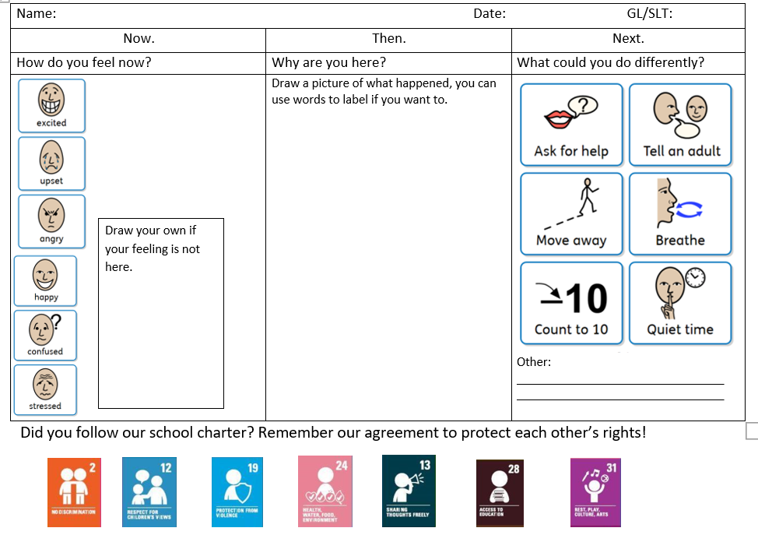

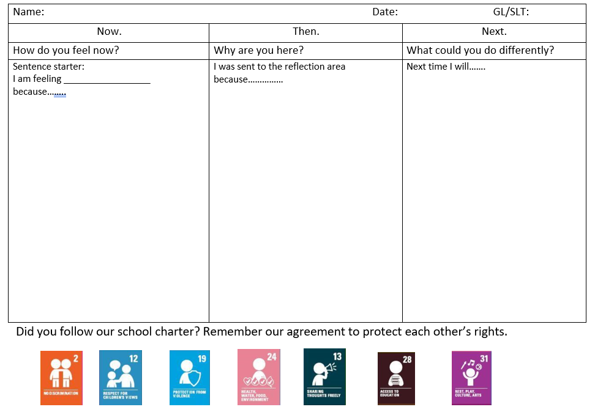

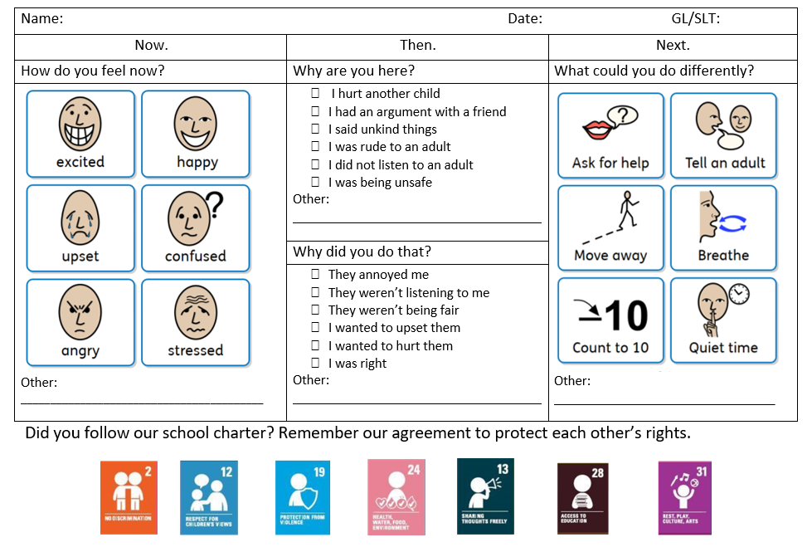

Appendix 3.1

Behaviour Policy – Covid-19 Addendum

We continue to create a safe and stimulating environment for pupils at Springfield Junior School. As a school, we encourage all children to respect themselves and the others around them. The current pandemic has resulted in a number of changes being made in school. This addendum should be read alongside the Behaviour, Online Safety and IT Acceptable Use (including Remote Learning) policies. Through staff training, all employees are aware of what signs pupils may show when exhibiting Covid symptoms. In light of all changes in protocols, children continue to work within classes/year groups and limit the sharing the equipment.

Hygiene
To combat the spread of Covid we have stringent hygiene protocols in place. Children are required to wash hands regularly and also sanitize when entering or leaving workspaces. Through careful monitoring of staff, the implementation of the hygiene protocols will be closely adhered to. We continue to follow a ‘catch it, bin it, kill it’ approach in school. Changes in classrooms have lead to clear sanitizing stations and also changes to bins which stem the spread of Covid. All pupils are reminded to keep their hands away from their faces, mouth, nose or eyes whilst in school. Appropriate consequences will be provided if pupils deliberately break Covid protocols and endanger stakeholders around them.

Behaviour
The measures put in place around Covid-19 are implemented to safeguard all people within our school community. With reference to relevant guidance from the government, Covid protocols will be amended in school and these changes shared with all stakeholders.

There may be instances where a child deliberately refuses to follow these safety measures. If this is the case, appropriate action will be taken and the steps outlined in Appendix 1.1 and Appendix 1.2 will be followed. Any incidents relating to this will be shared with parent/carers and also recorded on CPOMs. The consequences provided will dealt with, in the first instance, by the Year Leaders and these will take into account current Covid protocols and maintain bubbles.

Mental Health
The current pandemic has created some anxiety for pupils, staff and parents alike. There have been many experiences observed during recent lockdowns and often the behaviours seen in school may be a result of this.

There may be a number of behaviours which could be observed and linked to how pupils are feeling:
- Anxiety
- Challenging behaviour
- Anger
- Hyperactivity

All staff are passionate about pupils integrating back into school life. There may be instances where classes or individuals have had to isolate for a sustained period of time. If this is the case, our Family Support Worker, Dave Rycraft, and Thrive Lead, Kate Whitmore, work alongside families to provide support and bespoke sessions within school.

SEND
Pupils with SEND, or other complex needs, may find the lack of routine and uncertainty during the pandemic creates a high level of anxiety, including pupils with autism.

With a strong focus on the Thrive approach in school, staff are aware that the behaviours observed are a reflection of unmet needs. The school will support children in school with bespoke SEL interventions and work collaboratively with parent/carers to ensure that children are being provided with the correct support.

Remote Learning
During periods of remote learning, the school’s expectation is that children uphold the behaviour expectations outlined within this Behaviour Policy. Children must continue to be polite and respectful to all members of our school community.

Google Classroom, and school email addresses, should be the only form of communication with pupils. No other forms of communication, including social media, should be used by staff or pupils. The expectations in the IT Acceptable Use (including Remote Learning) and Code of Conduct for Employees Policy should be upheld. The Remote Learning Policy clearly states the expectations for live and online lessons which will stem any potential safeguarding incidents involving peer-on-peer abuse – minimum lesson attendance numbers and staff behaviours are clearly outlined in the Remote Learning Policy found on the school’s website.

Any concerns raised online should be immediately reported to Scott Reynolds, Online Safety Lead, who will take appropriate and timely action.

