Springfield Junior School
Kitchener Road, Ipswich, Suffolk IP1 4DT
Telephone: (01473) 741300
E-mail: admin@springfieldjuniors.net
Head teacher: Mrs J. Viner
SpringfieldJuniorSchool
Kitchener Road, Ipswich, Suffolk IP1 4DT
Telephone: (01473) 741300 Fax: (01473) 747485
E-mail: ad.springfield.j@talk21.com
Headteacher: M Lynch BSc



Spring into Learning!

Dear Parents and Carers,

Thank you for attending our Parent Play day!
OPAL stands for ‘Outdoor Play And Learning’ It is a programme designed to improve opportunities for play in schools. We decided to embark on this journey due to our lack of space and resources. Playtimes make up 20% of pupils time at school and, done right, can help children develop skills such as communication, creativity, collaboration, curiously and risk management among many many more! We have developed every inch of our site to allow more opportunities to play. We are constantly developing and continually improving what we offer at lunchtime.

Our vision is to ensure that: Children at SJS have as many opportunities to explore different types of play as possible.

We have different play zones with rotating activities. Here is a site map of our current provision.

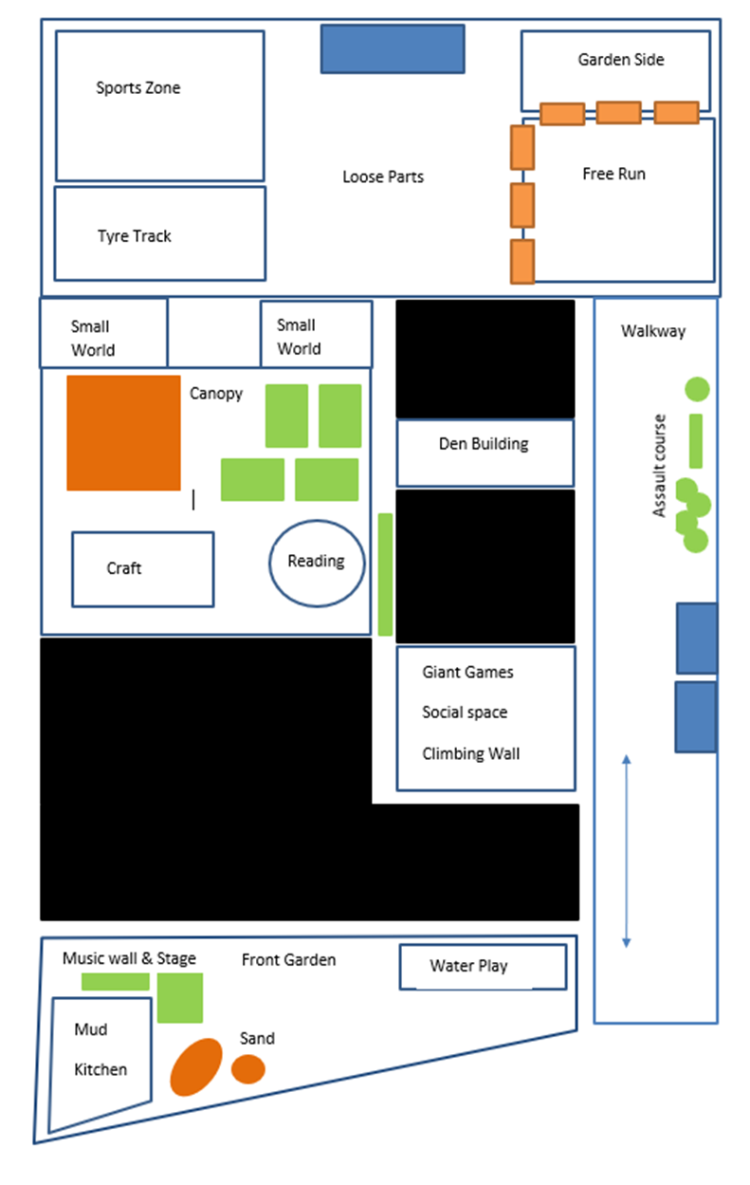

We introduce new activities or equipment through frequent OPAL assemblies and our incredible play team meet regularly to discuss the provision and develop new ideas!

A big part of the OPAL approach is to help children understand risks. Rather than saying ‘No’ we will say ‘Do you feel safe?’. This encourages them to consider if the play they are participating in is worth or relative to the risks involved, say of a splinter or a graze. We feel this is an important part of children’s development and want our children to develop independence and resilience.

Attached is a newsletter written by our play detectives to share what/where/how they like to play and what they recommend.

We hope that you enjoy exploring the different play zones with your children today!

