Times table Progression 2025
Times tables need to be explicitly taught to allow children to make connections between different concepts and support them with fluency when solving increasingly challenging number problems.
Times tables are taught (not just practised) at least 4 times per week. Short sessions, taught regularly are enough to have a positive impact on the children’s ability to make connections and recall facts. This in turn will support children to develop fluency. Times table knowledge is build up incrementally throughout Year 3 and 4. Teachers should build on children’s skills of doubling and halving to build confidence in skills. In Year 3, this weekly times table teaching is taught from the beginning of the spring term to allow for addition and subtraction number fact fluency teaching to be the focus during autumn Term. Year 4 will teach discrete times tables sessions from the beginning of the Autumn term through the Mastering Number programme which will continue into Years 5 where pupils will have an opportunity to consolidate multiplication facts, connect contexts to equations and bigger numbers. Children’s fluency in times tables should be assessed within Year 6 with gaps in fluency identified and taught. Children should continue to practise and develop fluency using TTRS for homework and other methods deemed appropriate by the class teacher. Intervention groups will be used where additional support is required. Children should be able to recall the tables in any order and complete missing number facts for multiplication and related division facts.

Mastering Number
This project enables pupils in Years 4 and 5 to develop fluency in multiplication and division facts, and a confidence and flexibility with number that exemplifies good number sense. Pupils in KS2 will develop automaticity in multiplication and division facts through regular practice. Teachers will develop an understanding of how pupils progress in their knowledge and understanding of multiplicative concepts.
At Springfield, we teach times tables through the Mastering Number programme in Year 4 and Year 5. In Year 3 and 6, teachers use other methods which expose connections between different multiples to support children’s deep understanding e.g. counting stick, White Rose and NCETEM resources. Recall of times table facts support children to apply this knowledge to different problems (including multiplication, division and fractions) as it reduces the load on the working memory, allowing children to focus on solving problems.
Resources
Mastering Number – https://www.ncetm.org.uk/maths-hubs-projects/mastering-number-at-ks2/
Times Tables in 10 minutes - YouTube is a great 10 minute demonstration on teaching tables using the counting stick.
NCETM Mastery resources (Spine 2 is a good resource to explore for looking at different representations of times table to help children develop a deep conceptual understanding. Multiplication and Division | NCETM
Other strategies for consolidation and fluency are used as deemed appropriate by class teachers.

Times table Rock stars
TTRS is used as a practise tool for children to practise the instant recall of their times tables. This is used weekly as homework. Teachers use the ‘stats’ and heat map function to understand areas of strength and weakness for their classes and for individual students. Each year group will ‘launch’ TTRS with a ‘rock and roll’ day where children can come dressed as a rock star and they will stop what they are doing and practise their times tables at different times in the day. For year 3 the ‘launch day’ will take place at the beginning of the spring term. For all other year groups this will take place in the first half of the autumn term.
Children should undertake a half-termly check in ‘gig’ which allows for tracking of progress.
Each year group should set homework on TTRS to be completed each week. This should be checked by the class teacher and children who have not completed the homework should be given the opportunity to do so at school.
In year 3, homework should be set in the garage as this will tailor the questions to the tables children are working on.
In year 4, homework should reflect the MTC Prep Schedule.
In year 5 and 6 children should have homework set in the studio to increase their ‘rock speed’ though teachers may choose to set garage for pupils whose times table knowledge still needs to be consolidated.
Once children have completed their set homework they can play in any of the other game types (some children like to play studio as it gives them a rock speed and this can certainly be encouraged.

Assessment
Heatmaps are used to track the progress of pupils.
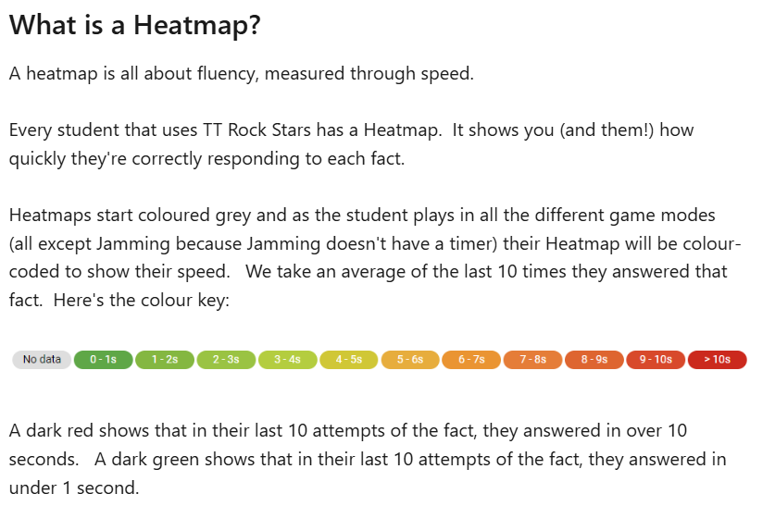
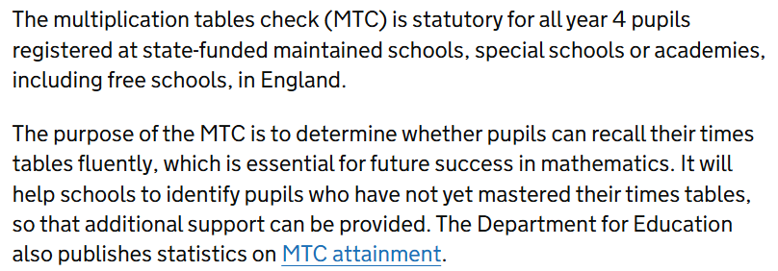
MTC Check

Year 3
 | Table to be taught | Connections to expose
Spring 1 Weeks 1 and 2 | Consolidate and recall multiple of 2, 5, and 10 (from Year 2) up to 12x | 2 times table is double 1s. All even numbers. Even numbers can be halved equally.  10 times table is double 5s (5s is half 10s). 10 times tables always have 0 in the ones. 5s always have 0 or 5 in the ones. If it is divisible by 10 it is divisible by 5.
Spring 1 Week 3 and 4  Week 5 and 6 | Teach multiples of 3. Fluent counting in multiples, from any multiple of 3.  Teach multiples of 4. Fluent counting forwards and backwards, from any multiple of 4. | Highlight patterns of odd, even. Use doubling to expose connections and make them easier to remember.  Expose connection of double 2 times table. Compare 2s with 4s to notice what is the same and different. Expose understanding that 4s are even, 2 is half of 4 so to divide by 4 we can half and half again.
Spring 2 Week 1 and 2 | Consolidate and recall multiples of 3 (see above) | Continue to discuss connections between multiples of 2 and 4. Children should be working at instant recall of multiples of 2, 5, 10, 3 and 4 by February half term.
Spring 2 Week 3 and 4  Week 5 | Recall and consolidate multiples of 3 and 4  Teach multiples of 8. Fluent counting in multiples of 8 from any multiple of 8, forwards and backwards | Expose connection to 4 times table and that 8s is 2x2x2 (double and double again)  All 8s are even (like the 2s and 4s). To divide by 8 we can half and half again.
Summer 1 Week 1 and 2 | Recall and consolidate multiples of 4 and 8 (see above)  Teach multiples of 6. Fluent counting in multiples of 6 forwards and backwards. | Expose connections with 3 times table. Notice patterns in the 6s. 6s are all even, but 3s are odd, even odd. Why is that? Is a number in the 3s always in the 6s? Is a number in the 6s always in the 3s?
Summer 1 week 3 and 4 | Recall and consolidate  Multiples of 2, 5 and 10
Summer 1 week 5 and 6 | Recall and consolidate  Multiples of 3 and 6
Summer 2 week 1 and 2 | Recall and consolidate 4s and 8s
Summer 2 week 3 and 4 | Recall and consolidate all taught tables from Y3.
Summer 2 week 5 and 6 | Recall and consolidate all taught tables from Y3. | By the end of Year 3, children should be able to fluently recall multiples of 2, 3, 4, 5, 8 and 10.  Recall of 6s will be fluent for some children.

Year 4 and Year 5 – Follow the Mastering Number Programme
Year 6 – Identify gaps in the autumn term using Heatmaps and teach to the gaps.

