Unique Policy Number: 36


Supporting Children with
Medical Conditions Policy

Appendix 1: Model Process for Developing Individual Healthcare Plans
Appendix 2: Individual Healthcare Plan
Appendix 3: Parental Agreement for Setting to Administer Medicine
Appendix 4: Risk Assessment Template – Children With Medical Needs

Appendix 1

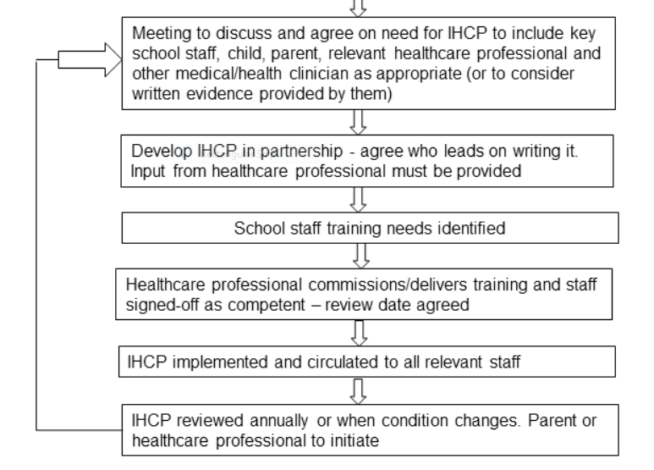
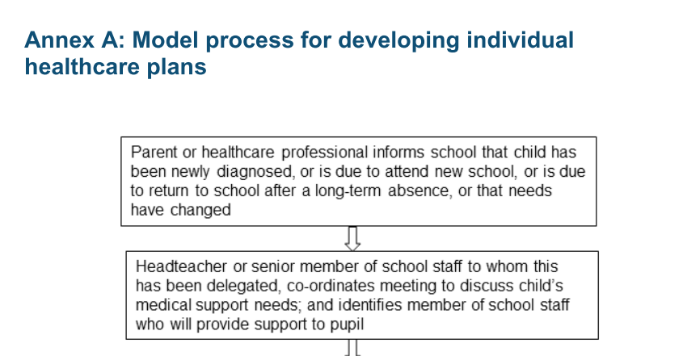

Source
Supporting Pupils at School with Medical Conditions
Statutory Guidance Spetember 2014

Appendix 2
Individual Healthcare Plan |  | 
Name of school/setting
Child’s name
Group/class/form
Date of birth
Child’s address
Medical diagnosis or condition
Date
Review date
Family Contact Information
Name
Relationship to child
Phone no. (work)
(home)
(mobile)
Name
Relationship to child
Phone no. (work)
(home)
(mobile)
Clinic/Hospital Contact
Name
Phone no.
G.P.
Name
Phone no.

Who is responsible for providing support in school

Describe medical needs and give details of child’s symptoms, triggers, signs, treatments, facilities, equipment or devices, environmental issues etc

Name of medication, dose, method of administration, when to be taken, side effects, contra-indications, administered by/self-administered with/without supervision

Daily care requirements

Does the child have an EHCP or SEND Learning Plan?
Specific support for the pupil’s educational, social and emotional needs:

Arrangements for school visits/trips etc

Other information

Describe what constitutes an emergency, and the action to take if this occurs

Who is responsible in an emergency (state if different for off-site activities)

Plan developed with

Date School Nursing Team informed of plan

Staff training needed/undertaken – who, what, when

Form copied to

Legal disclaimer
I understand that neither the Headteacher nor anyone acting on his/her authority, nor the governing body, nor The Children’s Endeavour Trust will be liable for any illness or injury to the child arising from the administering of the medication or drug unless caused by negligence of the Headteacher, the person acting on his/her authority, the governing body or The Children’s Endeavour Trust, as the case may be.

Parent/Carer Signature __________________________ Date _____________

Setting Signature __________________________ Date _____________

Date to be reviewed __________________________
(Unless there is a need to review at an earlier date)

Appendix 3
PARENTAL AGREEMENT FOR SETTING TO ADMINISTER MEDICINE

The school/setting will not give your child medicine unless you complete and sign this form, and the school or setting has a policy that the staff can administer medicine.

Date for review to be initiated by
Name of school/setting
Name of child
Date of birth
Group/class/form
Medical condition or illness
Medicine
Name/type of medicine
(as described on the container)
Expiry date
Dosage and method
Timing
Special precautions/other instructions
Are there any side effects that the school/setting needs to know about?
Self-administration – y/n
Procedures to take in an emergency
NB: Medicines must be in the original container as dispensed by the pharmacy

Contact Details
Name
Daytime telephone no.
Relationship to child
Address
I understand that I must deliver the medicine personally to | [agreed member of staff]

The above information is, to the best of my knowledge, accurate at the time of writing and I give consent to school/setting staff administering medicine in accordance with the school/setting policy. I will inform the school/setting immediately, in writing, if there is any change in dosage or frequency of the medication or if the medicine is stopped.

Signature(s) Date

Record of medicine administered to an individual child
Name of school/setting
Name of child
Date medicine provided by parent
Group/class/form
Quantity received
Name and strength of medicine
Expiry date
Quantity returned
Dose and frequency of medicine

Staff signature

Signature of parent

Date
Time given
Dose given
Name of member of staff
Staff initials
Countersigned (name)
Countersigned (initials)
Email sent to primary guardian
Date
Time given
Dose given
Name of member of staff
Staff initials
Countersigned (name)
Countersigned (initials)
Email sent to primary guardian

Record of medicine administered to an individual child (Continued)

Date
Time given
Dose given
Name of staff member
Staff initials
Countersigned (name)
Countersigned (initials)
Email sent to primary guardian
Date
Time given
Dose given
Name of staff member
Staff initials
Countersigned (name)
Countersigned (initials)
Email sent to primary guardian
Date
Time given
Dose given
Name of staff member
Staff initials
Countersigned (name)
Countersigned (initials)
Email sent to primary guardian

Record of medicine administered to an individual child (Continued)

Date
Time given
Dose given
Name of staff member
Staff initials
Countersigned (name)
Countersigned (initials)
Email sent to primary guardian
Date
Time given
Dose given
Name of staff member
Staff initials
Countersigned (name)
Countersigned (initials)
Email sent to primary guardian
Date
Time given
Dose given
Name of staff member
Staff initials
Countersigned (name)
Countersigned (initials)
Email sent to primary guardian

Appendix 4
RISK ASSESSMENT TEMPLATE – CHILDREN WITH MEDICAL NEEDS

This template is provided to give guidance only – each school should aim to have children on site as early in a recovery period as possible. If the need is a long term need it is expected that adjustments will need to be made. Please consider all aspects of life including toileting / lunch and break times. Every school site is different as is every medical need please ensure the individual is considered and involved in the writing of this assessment.
Child’s Name: |  | DOB:
School: |  | Person completing form:
Brief description of child’s diagnosis/ difficulties:

Risk | Low | Medium | High | Description of Risk | Recommended Measures take to prevent/reduce risk (to include useful information which helps the pupil and/or professional improve engagement in teaching and learning lessons)
Risk to Self Toileting / access & egress to school / location in classroom

Risk to Others Mobility devices / behaviour / transmission

Vulnerability
(at risk from others) Break times / PE

Plans for positive risk taking where possible & acceptable, this would include a phased return to everyday activities:

Incidents occurring while at school which may result in a rewrite of this Assessment.
Date: | Description:

Signature(s) Date

